**Dropping the Substation Geometric Network**

1. Drop all versions except sde.default.  
    as sde run “delete from sde.versions where name<>’DEFAULT’;”
2. Run a compress from ArcCatalog.
3. Ensure there are no connections to the database.
4. Open a command prompt, log into sqlplus as EDGIS, and run the ‘pm_order_number_idx_delete.sql’ script at the following location:  
   <http://edappgistfsprd1:8080/tfs/ElectricDistCollection/EDAMGIS/_versionControl#path=%24%2FEDAMGIS%2FSource_Development%2FDocumentation%2FData+Model%2FSchema%2FIndexes&_a=contents>
5. Connect to the database in ArcCatalog as business owner
6. Add the following buttons to the toolbar: Unregister as Versioned, Register as Versioned, Initialize Electric Trace Weights

Will look like:  

1. Export the connectivity rules via GDBDesigner or use a provided file from the DataModel Team.
2. Select the SubstationDataset
3. Unregister as Versioned.
4. Open the SubstationDataset and select the Network
5. Delete it
6. Steps 12 – 14 should be run on a batch server for access to the log files.
7. Browse to the following location and delete any existing “FdrMgrWeightInitSql.txt” and “FdrMgrWeightInitLastStatement.txt” files.  
   Documents and Settings\[User]\Application Data\Miner and Miner\ArcFM  
   or  
   Users\[User]\AppData\Roaming\Miner and Miner\ArcFM
8. Press “Initialize Electric Trace Weights” button : 
   1. This step must be verified that it ran successfully. It does *not* tell you if anything failed, and success must be determined by reviewing the log files.
   2. Browse to the same location as above and use the “FdrMgrWeightInitLastStatement.txt to gauge the progress. It will execute the sql statements in “FdrMgrWeightInitSql.txt” file in order.
   3. When finished, the statement listed in “FdrMgrWeightInitLastStatement.txt” will match the very last statement in “FdrMgrWeightInitSql.txt” file. If it doesn’t, then the initialize electric trace weights failed!
9. Right click on the Dataset and select ‘New Geometric Network’
10. Name: SubGeometricNetwork.
11. Leave the snapping set to **NO** (Unless this is an initial load of new data mostly used in conversion, never again!)
12. Select the feature classes you want in the network

|  |  |  |  |
| --- | --- | --- | --- |
| **Number** | **Feature Name** | **Role In Network** | **Source or Sink** |
| 1 | SUBBusBar | Simple Edge |  |
| 2 | SUBCapacitorBank | Simple Junction |  |
| 3 | SUBCurrentTransformer | Simple Junction |  |
| 4 | SUBElectricStitchPoint | Simple Junction | Source |
| 5 | SUBExtraWinding | Simple Junction |  |
| 6 | SUBFuse | Simple Junction |  |
| 7 | SUBInterruptingDevice | Simple Junction |  |
| 8 | SUBLightingArrestor | Simple Junction |  |
| 9 | SUBLink | Simple Junction |  |
| 10 | SUBMtu | Simple Junction |  |
| 11 | SUBOHConductor | Simple Edge |  |
| 12 | SUBPotentialTransformer | Simple Junction |  |
| 13 | SUBReactor | Simple Junction |  |
| 14 | SUBRiser | Simple Junction |  |
| 15 | SUBStationTransformer | Simple Junction |  |
| 16 | SUBSwitch | Simple Junction |  |
| 17 | SUBTie | Simple Junction |  |
| 18 | SUBTransformerBank | Simple Junction |  |
| 19 | SUBUGConductor | Simple Edge |  |
| 20 | SUBVoltageRegulator | Simple Junction |  |

1. Press next

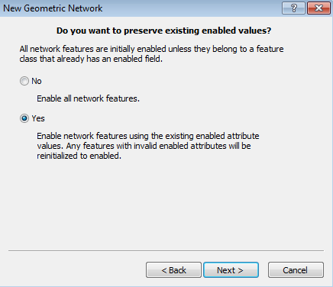

1. Change the role for **SUBElectricStitchPoint** to SOURCE like below

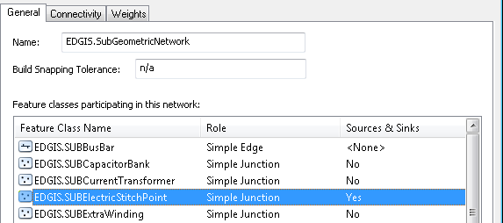

1. After all set hit next button.
2. Assign **MMElectricTraceWeight** to the features (select the ElectricTraceWeight field) (you must spell exactly as written – case sensitive)

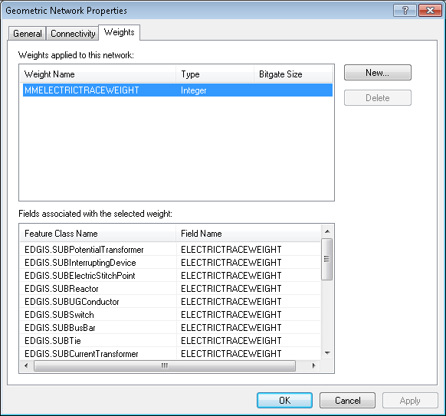

* 1. NOTE Make sure you get all features. Many people have missed this step and it will cause you to rebuild the whole network again.

1. Review the summary page and hit next
   1. The actual build of the network may take a long time. Please do not kill the ArcCatalog application, it is running, honest.
2. Use GDB Designer to load the connectivity rules, using the file created above.

**NOTE:** If there is no other network to rebuild, continue here, otherwise do up to this point and come back to this document once all of them are to this point

1. Register as Versioned
2. Right click the SubstationDataset and select ‘Add Global IDs…’.
3. Select the Substation dataset – right click and select ArcFM Solution Object Converter

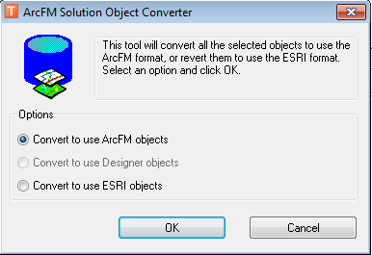

1. Run “Inspect/Fix Source Weights” by right clicking on the network and selecting the option under the Feeder Manager menu.
   1. This is a verification step. If it reports anything as incorrect, then the initialize electric trace weights failed somewhere and it needs to be analyzed.
2. Run Trace all feeders, by right clicking on the network, if the data has been appended or changed in this process.

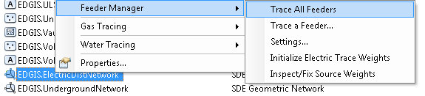

Notes:

1. All permissions must be reassigned because the data was versioned and unversioned.
2. Log into sqlplus as edgis and run the ‘pm_order_number_idx_create.sql’ script, located here:  
   <http://edappgistfsprd1:8080/tfs/ElectricDistCollection/EDAMGIS/_versionControl#path=%24%2FEDAMGIS%2FSource_Development%2FDocumentation%2FData+Model%2FSchema%2FIndexes&_a=contents>